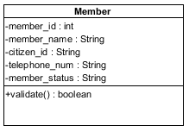

Attributes:

|  |  |  |  |  |
| --- | --- | --- | --- | --- |
| No. | Name | Description | Access Modifier | Data Type |
| 1. | member_id | The unique identifier of member. | Private | int |
| 2. | member_name | Name of member. | Private | String |
| 3. | citizen_id | Citizen ID of member. | Private | String |
| 4. | telephone_num | Telephone number of member. | Private | String |
| 5. | member_status | Status of member, which are active or not active. | Private | String |

Methods:

|  |  |  |  |  |  |
| --- | --- | --- | --- | --- | --- |
| No. | Name | Description | Access Modifier | Input Arguments | Return Type |
| 1. | validate | Verify status of member. If the status is “active”, it will return true. Otherwise, it will return false | Public | - | boolean |

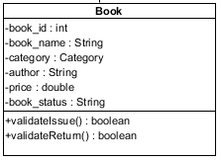

Attributes:

|  |  |  |  |  |
| --- | --- | --- | --- | --- |
| No. | Name | Description | Access Modifier | Data Type |
| 1. | book_id | The unique identifier of book. | Private | int |
| 2. | book_name | Name of book. | Private | String |
| 3. | category | Category of book | Private | Category |
| 4. | author | Author of book | Private | String |
| 5. | price | Price for rental the book | Private | double |

Methods:

|  |  |  |  |  |  |
| --- | --- | --- | --- | --- | --- |
| No. | Name | Description | Access Modifier | Input Arguments | Return Type |
| 1. | validateIssue | Verify status of book for issuing. If the status is “available”, it will return true. Otherwise, it will return false | Public | - | boolean |
| 2. | validateReturn | Verify status of book for issuing. If the status is “borrowed”, it will return true. Otherwise, it will return false | Public | - | boolean |

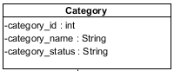

Attributes:

|  |  |  |  |  |
| --- | --- | --- | --- | --- |
| No. | Name | Description | Access Modifier | Data Type |
| 1. | category_id | The unique identifier of category. | Private | int |
| 2. | category_name | Name of category. | Private | String |
| 3. | category_status | Status of category. | Private | String |

Methods:

|  |  |  |  |  |  |
| --- | --- | --- | --- | --- | --- |
| No. | Name | Description | Access Modifier | Input Arguments | Return Type |
| - | - | - | - | - | - |

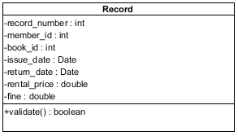

Attributes:

|  |  |  |  |  |
| --- | --- | --- | --- | --- |
| No. | Name | Description | Access Modifier | Data Type |
| 1. | record_number | The unique identifier of record. | Private | int |
| 2. | member_id | The unique identifier of member. | Private | int |
| 3. | book_id | The unique identifier of book. | Private | int |
| 4. | issue_date | Date that issue the book. | Private | Date |
| 5. | return_date | Date that return the book. | Private | Date |
| 6. | rental_price | Price of rental | Private | double |
| 7. | fine | Fine of rental | Private | double |

Methods:

|  |  |  |  |  |  |
| --- | --- | --- | --- | --- | --- |
| No. | Name | Description | Access Modifier | Input Arguments | Return Type |
| 1. | validate | Verify the correctness of record | Public | - | boolean |

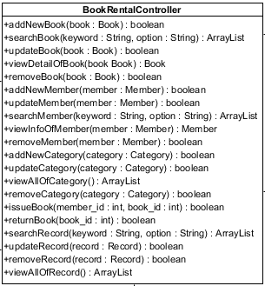

Attributes:

|  |  |  |  |  |
| --- | --- | --- | --- | --- |
| No. | Name | Description | Access Modifier | Data Type |
| - | - | - | - | - |

Methods:

|  |  |  |  |  |  |
| --- | --- | --- | --- | --- | --- |
| No. | Name | Description | Access Modifier | Input Arguments | Return Type |
| 1. | addNewBook | Add book’s data to the database | Public | book : Book | boolean |
| 2. | searchBook | Search book form the database by using keyword and option. | Public | keyword : String, option : String | ArrayList |
| If the keyword does not match. | Null |
| 3. | updateBook | Update book’s data to the database | Public | book : Book | boolean |
| 4. | viewDetailOfBook | View book’s data from the database | Public | book : Book | Book |
| 5. | removeBook | Update book status becomes to “removed” to the database | Public | book : Book | boolean |
| 6. | addNewMember | Add member’s data to the database | Public | member : Member | boolean |
| 7. | searchMember | Search member form the database by using keyword and option. | Public | keyword : String, option : String | ArrayList |
| If the keyword does not match. | Null |
| 8. | updateMember | Update member’s data to the database | Public | member : Member | boolean |
| 9. | viewInfoOfMember | View member’s data from the database | Public | member : Member | Member |
| 10. | removeMember | Update member status becomes to “not active” to the database | Public | member : Member | boolean |
| 11. | addNewCategory | Add category’s data to the database | Public | category : Category | boolean |
| 12. | updateCategory | Update category’s data to the database | Public | category : Category | boolean |
| 13. | viewAllOfCategory | View all category’s data from the database | Public | - | ArrayList |
| 14. | removeCategory | Update category status becomes to “not active” to the database | Public | category : Category | boolean |
| 15. | issueBook | Create record of issuing and update the book status to “borrowed” to the database | Public | member_id : int, book_id : int | boolean |
| 16. | returnBook | Update record of issuing and update the book status to “available” to the database | Public | book_id : int | boolean |
| 17. | updateRecord | Update record’s data to the database | Public | record : Record | boolean |
| 18. | searchRecord | Search record form the database by using keyword and option. | Public | keyword : String, option : String | ArrayList |
| If the keyword does not match | Null |
| 19. | viewAllOfRecord | View all record’s data from the database | Public | - | ArrayList |
| 20. | removeRecord | Remove record’s data from the database | Public | record : Record | boolean |

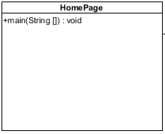

Attributes:

|  |  |  |  |  |
| --- | --- | --- | --- | --- |
| No. | Name | Description | Access Modifier | Data Type |
| - | - | - | - | - |

Methods:

|  |  |  |  |  |  |
| --- | --- | --- | --- | --- | --- |
| No. | Name | Description | Access Modifier | Input Arguments | Return Type |
| 1. | main | Used to run the system. | Public | String [] | void |